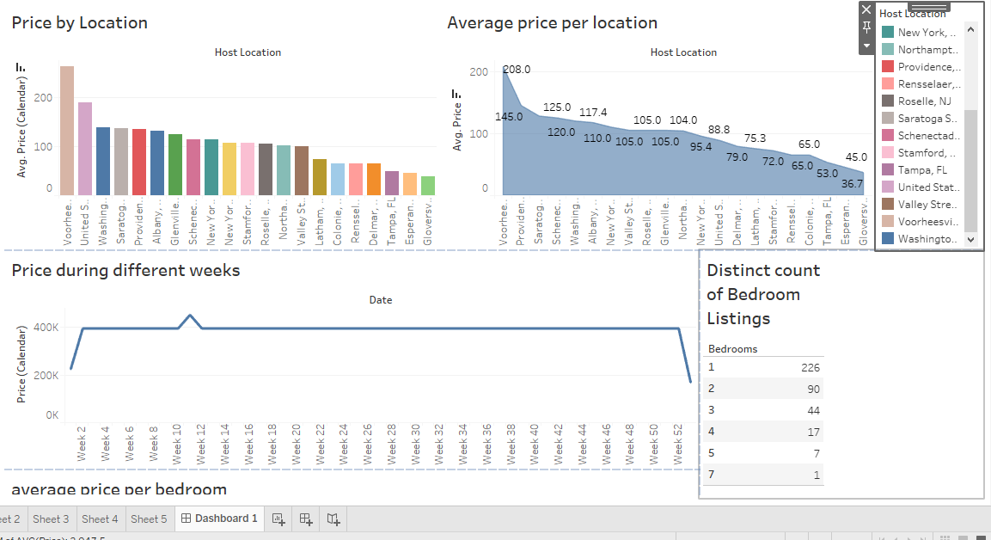

View this dashboard on tableau public [click here](https://public.tableau.com/views/AIRBNBPROJECT_17135503240860/Dashboard1?:language=en-US&publish=yes&:sid=&:display_count=n&:origin=viz_share_link)